In the Name of Allah, Most Gracious, Ever Merciful

Peace through the Messiah

Objective: To act on Hudhur’s (may Allah assist him with His Mighty Help) guidance of building upon our Muslims for Peace, Loyalty, and Life campaigns by informing people that peace can only be achieved through acceptance of the Messiah, Hazrat Mirza Ghulam Ahmad, peace be on him.

Work on devising this plan started immediately upon receiving Hudhur (ab)’s directions and went on for several weeks. An attempt was made to complete the work during the President’s Refresher Course December 2-4, 2011 but a final full fledged effort last weekend, December 17 - 18, 2011 succeeded by Allah’s Grace and Mercy in producing a draft plan herein humbly submitted for Hudhur (ab)’s kind consideration.

Target Audience: By and large our materials and efforts will target an audience that is 18-40 years of age, predominantly Christian, non-church-going 70% or more of whom believe in God [Footnote 1]. The Campaign will not have any geographic focus [Footnote 2] and the materials will be written using 8th grade education.

The Campaign: Robust and prepared to take on those who wish to enter into debates but the issue that will be presented will be that the only way to achieve peace today is by accepting the Messiah sent by God into the world to spread the truth and unite mankind and bring them back to God emphasizing absolute justice morality and unity. The Campaign will have doubly beneficial results, insha-Allah. In America, indeed in the whole world, no one else is taking on all those who are attacking Islam, the Holy Quran and the Holy Prophet and our proposed work is going to result in a very visible Campaign that will show that we are the ones who have the courage to take on all the enemies of the faith of Islam in a demonstrably peaceful and rational way. Apart from making Islam known more widely, it will also send a strong message to all Muslims that it is the Community of the Promised Messiah (as) that is carrying the flag of Islam, defending the honor of the Holy Prophet Muhammad (sa) and propagating the teachings of the Holy Quran.

External Goals: Based on a study of the US demographics we see that there are some 100 million people who fall into our target audience and our goal is to be able to reach at least 10 million of them in a manner that will yield us at least 10,000 solid contacts - sustained contact!

Internal Goals: To go on further uniting the Jama’at by strengthening the bonds with Khilafat; improving and making more efficient the communication and functioning of the Jama’at’s internal structures and continue involving more and more members from all age groups in tabligh regularly.

Muslims for Life: We considered carefully whether running the Muslims for Life Campaign this year even though we may be involved with the Peace through the Messiah work and came to the conclusion that we could execute both campaign if we take proper care and run a much simplified Muslims for Life Campaign. We all felt strongly that this should be repeated in 2012. It is a wonderful way to help save lives and communicate the life-giving message of Islam and its impact on all our other work will be extremely beneficial. A much simpler campaign requiring much less money and time should be possible to be undertaken without diminishing the goals we had set for ourselves last year. This would not hurt the Peace through the Messiah work, in fact it would be helpful.

Tools and Mechanisms: Learning and building from our previous campaigns more robust and functional technology and volunteer training and more efficient control and command structures will need to be developed and implemented in order to be able to handle the numbers of emails, calls and in-person contacts that are expected/required/aimed to be generated by this Campaign.

Flyer[Footnote 3]: Here are the flyers that encapsulates all the criteria discussed as best we could:

http://www.sajid.com/downloads/PTTM-Brochure-Long-Quote.pdf
http://www.sajid.com/downloads/PTTM-Brochure.pdf

FULL QUOTE from which we have taken the Promised Messiah (as) quote:

O mankind! hearken, this is the prophecy of God Who made the Heavens and the Earth. He will spread this Movement in all the countries and will give it supremacy over all through reason and arguments. Remember, no one will descend from heaven. All our opponents who are living at present will die and not one of them will see Jesus, son of Mary, descend from the sky and then their children who survive them will also pass away and none of them will see Jesus, son of Mary, coming down from the heaven. Generations of their posterity will also perish and they too will not see the son of Mary descending from heaven. Then God will create restlessness in their hearts; that the day of the glory of the Cross had passed away and the world had taken another turn but Jesus, son of Mary, had still not come down from the sky. Then all the wise people will discard this belief and the third century from today will not have completed when all those who had been waiting for Jesus, both Muslims and Christians will despair of his coming and entertaining misgivings shall give up their belief and there will be only one Faith in the world and one preceptor. I came only to sow the seed. That seed has been sown by my hands. It will now grow and blossom forth and none dare retard its growth. (The Promised Messiah (as) in Tazkira-tush-Shahadatain, published in October 1903)

Another quote suggested is as follows and this also seems to merit being included it seems:

“Woh kaam jis kay liyay khuda nay mujhay mamoor farmayay haiy …. ka namoona dikhlayoon.”
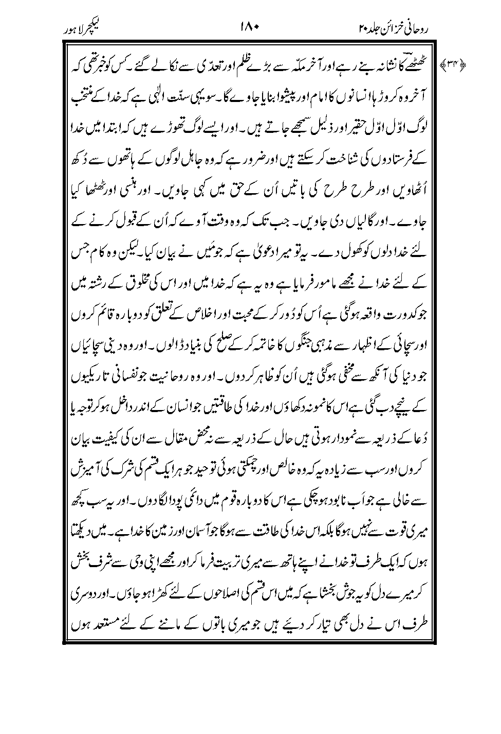
[Lecture Lahore, p. 47; Roohanee Khazian, Vol XX, p. 180]

“God has sent me into the world to remove the distance that has come between man and his Creator and re-establish a relationship of love and sincerity between him and his Lord; and to put a stop to religious wars by proclaiming the truth thereby creating religious harmony and reveal the religious truths that have long remained hidden from mortal eyes, and to display the true spirituality that lies buried under the darkness of selfish passions.” [Lecture Lahore, p.47; Roohanee Khazain, Vol. XX, p. 180]

The mission for which God has appointed me is to remove the rift that has
appeared between God and His creation and instead re-establish between them a relationship of love and sincerity. Likewise, by proclaiming truth, to end religious wars and lay the foundation for peace; and to reveal those spiritual truths that have disappeared from worldly sight and illustrate the example of spirituality that lies buried underneath the darkness of personal vanity.

A concern is with the very “whiteness” of the hands on the brochure and on the bus as displayed...it has been decided to make the color more brown/tan... less prone to giving rise to misunderstandings, insha-Allah!

The Plan: Following are the main items:

- A Very Visible Bus wrapped [entirely painted all around] in the “Peace through the Messiah” Campaign logo and colors would visit for one week at a time a University where a Debate would have previously been arranged by the local Ahmadiyya Muslim Students Association (AMSA). The Region’s Jama’ats would be involved in all the pre-debate efforts to garner massive media and public interest in the forthcoming debate. Every day the aim would be to attract at least a thousand visitors to walk through the Bus Exhibition and sign up for the Debate - our aim over five days of such efforts to attract a few hundred attendees at the debate and gain at least 500 to a 1,000 solid interested people.

- Website - will be the main tool for handling the media and public inquiries and enable those interested to talk with our trained tabligh contact handlers.

- Debates - the aim is to ask all 72 Jama’ats in the US to work in their areas to set up debates/functions where Major events could be planned at which the Bus would arrive with the Exhibition and try to attract major coverage in the media and the local and regional communities. We will enter into debates on topics that we consider relevant and acceptable to us and agree to acceptable moderators known for their impartiality. Topics under consideration are: No God, No Peace; Sharia Law; .. Our debaters will be Maulana Naseem Mahdi Sahib, Maulana Azhar Haneef Sahib, Imam Mubasher Ahmad Sahib, Amjad Mahmood Khan Sahib, Qasim Rashid Sahib, Dr. Faheem Younas Sahib, … All Ahmadi students and Khuddam will be involved insha-Allah. Where appropriate and deemed necessary selected Lajna members would be chosen to represent the Jama’at. Our plan is to challenge all the major prominent attackers of Islam, the Holy Quran and the Holy Prophet Muhammad (sa). We will even be prepared to take out ads and write op eds and send letters of challenge openly and through the media to invite such people to either stop maligning Islam, the Holy Quran or the Holy Prophet or accept our challenge and enter into a debate on the issue at hand moderated by independent moderators. Debates on Sharia law would be particularly welcome. Universities will NOT be the only venues - we would particularly want to go into areas where we feel the population would be more accepting of our message - inner cities, Florida, Harlem..
- Flyer Distribution - the aim is to distribute a million flyers during this Campaign; hopefully at each week-long bus event 100,000 or so flyers could be aimed to be handed out. Here it needs to be understood that detailed demographics will need to be obtained and researched for the areas where any debates are planned and the flyers would need to be delivered to apartment complexes and places where in the inner cities populations more accepting of our message are likely to be living...Khuddam from the areas competing to get the bus to come there and to hold a debate there will need to do their research and be able to demonstrate that they have done a full study of the area.

Initially, the idea is to try-out a one month Bus Tour and visit four Universities or other such locations where debates get arranged.. as described above.

TOUR BUS would have a full fledged Exhibition complete with Audio-Video components and materials for handing out and an area for people to sit and discuss.

The BUS would have the “Peace through the Messiah” logo wrap around as illustrated[Footnote 4].

http://www.sajid.com/downloads/PTTM-Bus-Wrap-PM.pdf
http://www.sajid.com/downloads/PTTM-Bus-Wrap.pdf

PRE-PLANNING/PREPARATION: The AMSA’s and local Jama’ats in each of the various parts of the US will have to do their preliminary reconaisance to see who best to debate with and make the necessary arrangements for the bus and the debate and the media and outreach etc etc..WE SHOULD MAKE THIS A COMPETITION perhaps amongst the various areas of the US and the top four will get the first shot at holding the event there....

Involvement of Local Jama’ats: Let us assume the FOUR areas who win are - say NORTH-EAST(NY); SOUTH (TX); UPPER-NE(Boston); NORTHWEST(CA) and the Jama’ats of the area would be invited to support the effort by helping arrange/promote/advertise..

MEDIA: Go and meet the media already known personally and get them involved/invited.

INVITE THEIR OWN UNDER TABLIGH PROSPECTS/CONTACTS

FLYER HANDOUTS: Go into the neighborhoods and hand out flyers and/or visit door to door

OUTREACH into local communities...

Essentially what we are saying is that the Jama’ats around each debate location would help make all arrangements needed for the BUS tour and the Debate.

GENERAL PLAN OF TOUR: One week per location; five days of ACTIVE and two days of Travel, set up, break down. 1,000 visitors per day should be minimum goal and we should be looking for 500 to a 1,000 contacts from each area. The idea is for the local AMSA to engineer a debate and then we arrive there with the bus on a certain date to advertise and promote the debate and have people look at our exhibition and thus drum up attendance at the debate...park it at a location that attracts the maximum attention..

VENUE: Debate should be held initially at a University Humanities Dept lecture theater or similar venue with about 200 to 500 capacity..

Later when this gets picked up or becomes a hugely controversial or popular thing we can think of bigger things/events/venue..

OUR AIM IS TO BE ABLE TO GET two to four thousand good contacts. So 5,000 people walking thru and 200 attending the debate and lots of media attention and we get maybe 500 to 1,000 contacts from each event/region.

BUDGET: Roughly, the total proposed budget for the one month bus tour campaign is estimated to be $140,000. Here is the breakdown:

Regional Expenses $60,000: 100,000 flyers for each region (400,000 flyers total $25,000); press and media (four times $2,500 = $10,000); debate set up and refreshments (four times $1,250 = $5,000); consumables, like books, t-shirts, pens, cd’s, dvd’s etc. water bottles, candies, miscellaneous (4 times $5,000 = $20,000).

Bus Preparation - $20,000 - Exhibition ($10,000), electronic audio-video materials ($5,000); wrap around paint ($3,000); Miscellaneous ($2,000)

Bus Rental Travel etc. - $60,000

An additional $160,000 would be needed, we estimate for the following: Advertising on buses, billboards, metro, etc. ($50,000); 600,000 additional flyers ($40,000), website ($10,000), CRM ($10,000), other consumables like T-shirts ($10,000), advertising for debate challenges ($40,000)

$300,000 Total Budget for the Full One Year [half from the 2011 - 12 and other half from 2012 - 13 fiscal years]

Control and Command:

Naseem Mahdi
Nasim Rehmatullah
Munum Naeem
Wasim Malik
Muhammed Chaudhry
Usman N. Choudhary
Waseem A. Sayed

Technology: Web, phone, database, CRM

Bus Management: Driver, Presenters, Security, Hospitality

Volunteer Management: Waqf-e-Aarzee

Response Handling: Phone, email and followup

Event Co-ordination: Regional Missionaries and Local Tabligh Secretaries

Press and Media:
- Op-ed:
- National TV/Radio:
- Local/Regional TV/Radio:

Marketing Ads:
- Print Newspaper/Magazines:
- Online banner ads, search:
- Highway Billboards, buses, Metro:

Distribution: Flyers, books, Holy Quran

Paraphernalia: T-shirts, Banners, Pens,...:

Role of Auxiliaries:

Respected Maulana Naseem Mahdi Sahib has discussed with the Heads of the Auxiliaries and alhamdolillah everyone has expressed their willingness to work together with the Jama’at and roles and duties will be divided up and assigned as previously with the Muslims for Life Campaign.

Use of Jama’at Structure:

Missionaries: The role of the missionaries was wonderful in the Muslims for Life Campaign. They acted as facilitators and trained and directed and guided the Jama’ats under their care. In every area the missionaries were prominently featured in the media news and conveyed the life-giving message of Islam wonderfully.

Presidents:
Tabligh Secretaries:
Audio-Video Secretaries:
PA Secretaries:
Umoor-e-Aama Secretaries:
Ziafat Secretaries:

Prepared on behalf of the Tabligh and Media Teams by:

Waseem A. Sayed, PhD
Administrative Liaison

Approved by Huzur(aba)

This is the main segment of the population that we are designing the flyer for, and will be keeping in mind as we develop our materials. The aim is not to ignore the other segments of the population. However, it is not possible to satisfy the needs of everyone with just one flyer or one strategy. So the other segments of the population will, insha-Allah, be served through their respective Desks using other strategies and materials made to fulfill those specific needs.
Again here the idea is not to try and design a campaign aimed, for example, at the typical NY population mix but rather to keep in mind every part of the US. The special needs of Spanish speaking population and the African-American population or the Bangali speaking and Arabic speaking areas/populations will, insha-Allah, be catered for in special efforts led by their respective Desks.
See the attached Flyer
There are two proposals and direction requested as to which we should use.

