In the Name of Allah, Most Gracious, Ever Merciful

MuslimsForPeace Event registration system:

For info email: events@muslimsforpeace.org

EVENT REGISTRATON FORM

To register an event goto: http://www.muslimsforpeace.org/events/register-event/

Your Details
Local Chapter Point of Contact: (Note that this information will be emailed automatically to guests when they register for the event listed.)

Name – PLEASE PUT YOUR <#First #Last>
Email

Event Name:
This title needs to descriptive for your event.. You can do something like “Messenger of Peace Conference of Silver Spring”

Where
Location:
Make sure to DESCRIBE your location properly; Name should be in full text and descriptive,
Ex: “Baitur Rahman Mosque”,
“George Mason University, Fairfax”
“The Church of the Living God CWFF”

Details
In the details section, add your local chapter info, this text can be formatted so you can copy and paste pictures and text from MS-WORD or any editing program. If you wish to list your local RSVP phone and other details, add them all here.

Category: Interfaith Event, Mosque Open House, Muhammad: Messenger of Peace Conference, Muslims For Life Campaign, Muslims For Loyalty Campaign, Muslims For Peace Campaign, Promised Messiah Day, etc.

Choose: Muhammad: Messenger of Peace Conference

Event Image
You can upload an image of the location or your mosque or venue or logo or something that is familiar to the local population.
Bookings/Registration
Enable registration for this event:
Please always make sure to check this box.

All the rest of the fields below can remain default, you do not need to enter them, but you can add the number of spaces if you like.

Name Standard Ticket ?
Price
Spaces10 ?
Available from to ?
Bookings must order between and spaces. ?
Description
Members Only?
Required? ?
Total Spaces Individual tickets with remaining spaces will not be available if total booking spaces reach this limit. Leave blank for no limit.
Booking Cut-Off Date 12:00 AM This is the definite date after which bookings will be closed for this event, regardless of individual ticket settings above. Default value will be the event start date.

ONCE You submit your event, it will be approved by our team in 24 hours and the link will become active.

TO FIND YOUR EVENT

Goto: http://muslimsforpeace.org/events

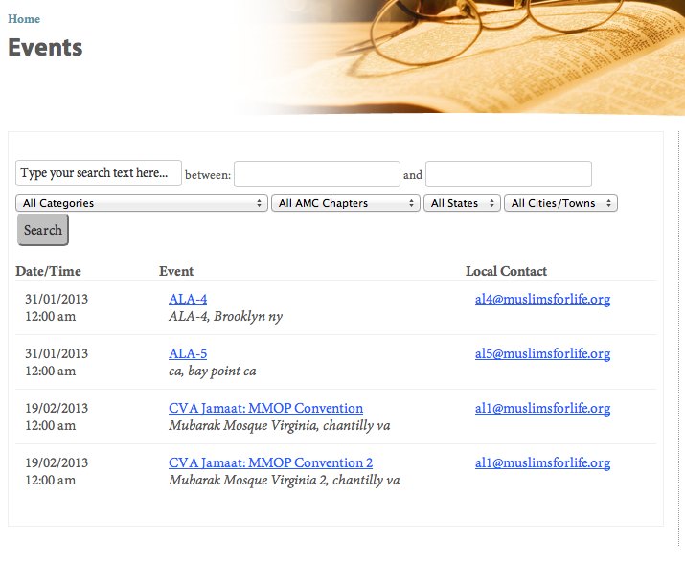
Click on the event Name: to choose your event

The URL for your event
will be in your web browser address bar

Example:
http://muslimsforpeace/events/cva-jamaat-mmop-convention/

You can email this link to all your contact and can also list this on your local flyer insert.

TO have guests RSVP to your event
On the event detail page: use the booking form:

