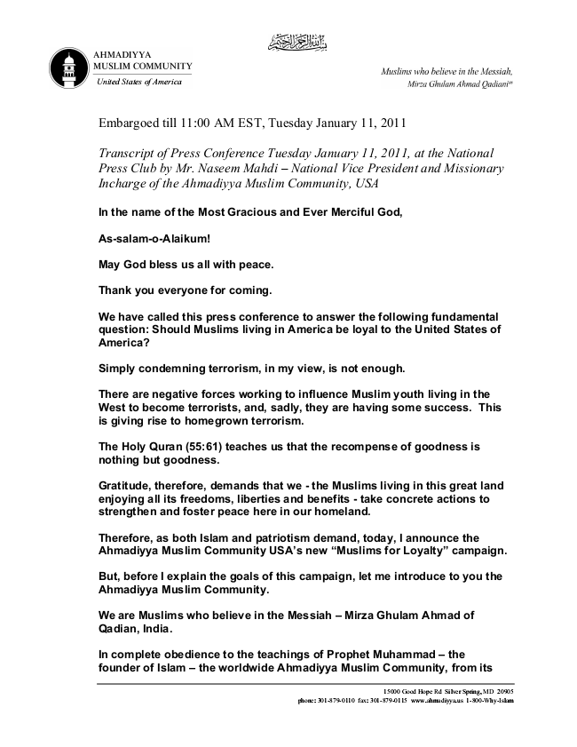

United States of America
Embargoed till 11:00 AM EST, Tuesday January 11, 2011
Transcript of Press Conference Tuesday January 11, 2011, at the National Press Club by Mr. Naseem Mahdi – National Vice President and Missionary Incharge of the Ahmadiyya Muslim Community, USA
In the name of the Most Gracious and Ever Merciful God,
As-salam-o-Alaikum!
May God bless us all with peace.
Thank you everyone for coming.
We have called this press conference to answer the following fundamental question: Should Muslims living in America be loyal to the United States of America?
Simply condemning terrorism, in my view, is not enough.
There are negative forces working to influence Muslim youth living in the West to become terrorists, and, sadly, they are having some success. This is giving rise to homegrown terrorism.
The Holy Quran (55:61) teaches us that the recompense of goodness is nothing but goodness.
Gratitude, therefore, demands that we - the Muslims living in this great land enjoying all its freedoms, liberties and benefits - take concrete actions to strengthen and foster peace here in our homeland.
Therefore, as both Islam and patriotism demand, today, I announce the Ahmadiyya Muslim Community USA’s new “Muslims for Loyalty” campaign.
But, before I explain the goals of this campaign, let me introduce to you the Ahmadiyya Muslim Community.
We are Muslims who believe in the Messiah – Mirza Ghulam Ahmad of Qadian, India.
In complete obedience to the teachings of Prophet Muhammad – the founder of Islam – the worldwide Ahmadiyya Muslim Community, from its
15000 Good Hope Rd Silver Spring, MD 20905 phone: 301-879-0110 fax: 301-879-0115 www.ahmadiyya.us 1-800-Why-Islam

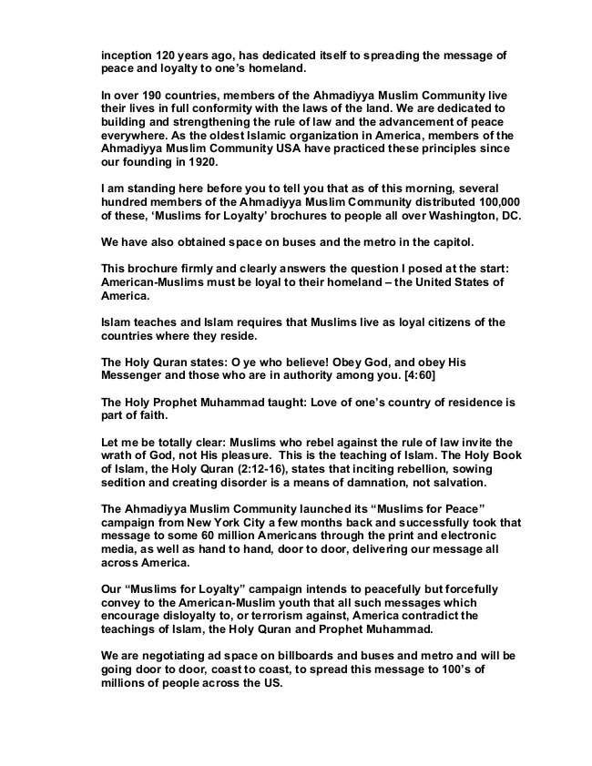

inception 120 years ago, has dedicated itself to spreading the message of peace and loyalty to one’s homeland.
In over 190 countries, members of the Ahmadiyya Muslim Community live their lives in full conformity with the laws of the land. We are dedicated to building and strengthening the rule of law and the advancement of peace everywhere. As the oldest Islamic organization in America, members of the Ahmadiyya Muslim Community USA have practiced these principles since our founding in 1920.
I am standing here before you to tell you that as of this morning, several hundred members of the Ahmadiyya Muslim Community distributed 100,000 of these, ‘Muslims for Loyalty’ brochures to people all over Washington, DC.
We have also obtained space on buses and the metro in the capitol.
This brochure firmly and clearly answers the question I posed at the start: American-Muslims must be loyal to their homeland – the United States of America.
Islam teaches and Islam requires that Muslims live as loyal citizens of the countries where they reside.
The Holy Quran states: O ye who believe! Obey God, and obey His Messenger and those who are in authority among you. [4:60]
The Holy Prophet Muhammad taught: Love of one’s country of residence is part of faith.
Let me be totally clear: Muslims who rebel against the rule of law invite the wrath of God, not His pleasure. This is the teaching of Islam. The Holy Book of Islam, the Holy Quran (2:12-16), states that inciting rebellion, sowing sedition and creating disorder is a means of damnation, not salvation.
The Ahmadiyya Muslim Community launched its “Muslims for Peace” campaign from New York City a few months back and successfully took that message to some 60 million Americans through the print and electronic media, as well as hand to hand, door to door, delivering our message all across America.
Our “Muslims for Loyalty” campaign intends to peacefully but forcefully convey to the American-Muslim youth that all such messages which encourage disloyalty to, or terrorism against, America contradict the teachings of Islam, the Holy Quran and Prophet Muhammad.
We are negotiating ad space on billboards and buses and metro and will be going door to door, coast to coast, to spread this message to 100’s of millions of people across the US.

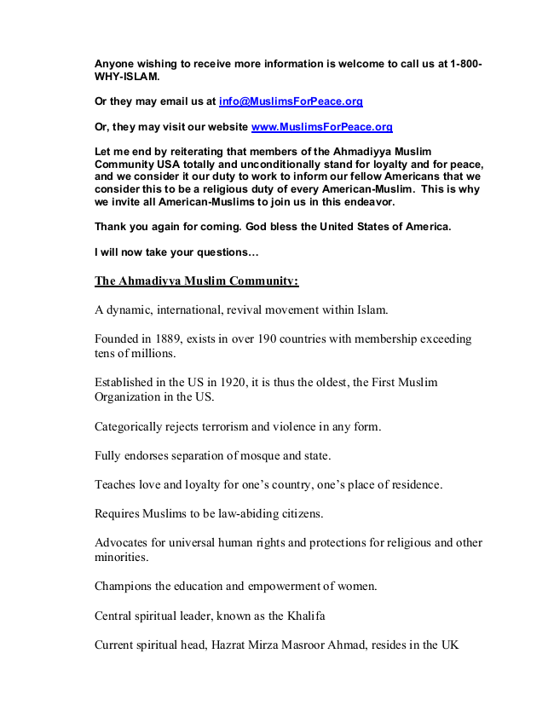

Anyone wishing to receive more information is welcome to call us at 1-800- WHY-ISLAM.
Or they may email us at info@MuslimsForPeace.org
Or, they may visit our website www.MuslimsForPeace.org
Let me end by reiterating that members of the Ahmadiyya Muslim Community USA totally and unconditionally stand for loyalty and for peace, and we consider it our duty to work to inform our fellow Americans that we consider this to be a religious duty of every American-Muslim. This is why we invite all American-Muslims to join us in this endeavor.
Thank you again for coming. God bless the United States of America.
I will now take your questions...
The Ahmadiyya Muslim Community:
A dynamic, international, revival movement within Islam.
Founded in 1889, exists in over 190 countries with membership exceeding tens of millions.
Established in the US in 1920, it is thus the oldest, the First Muslim Organization in the US.
Categorically rejects terrorism and violence in any form.
Fully endorses separation of mosque and state.
Teaches love and loyalty for one’s country, one’s place of residence.
Requires Muslims to be law-abiding citizens.
Advocates for universal human rights and protections for religious and other minorities.
Champions the education and empowerment of women.
Central spiritual leader, known as the Khalifa
Current spiritual head, Hazrat Mirza Masroor Ahmad, resides in the UK

