In the Name of Allah, Most Gracious, Ever Merciful
Muhammad (PBUH) - Messenger of Peace

Objective: One Jalsa By Every Jama’at with Minimum Attendance by 150 Non-Ahmadi Guests; Gift some 10,000 copies of “Life of Muhammad (sa)” & “True Love for the Holy Prophet” and get 10,000 additional new contacts in our National Tabligh Database. The Campaign: Hold Seeratun Nabi Jalsas, nationwide, during a two three month window, “Muhammad(sa) - Messenger of Peace.” Venue: Local Mosques/Mission House of Every Jama'at; Date: March 5, 6 or 7, 2013 or March 12,13,or 14, 2013; Day: Should be Tuesday, Wednesday or Thursday; Time: 7:30 PM - 9:30 PM Local Time;

Program: 7:30 PM:

HEREINBELOW is a DRAFT of SUGGESTED WORDINGS we can use....please tailor as you deem best...

7:30 PM Chairman’s Opening Remarks:

AssalamoAlaikum! Greetings of peace! Thank you all for joining us as we discuss the Prophet of Islam. Much has been said by people about Muhammad, the Holy Prophet of Islam, may peace and blessings of Allah be upon him (this is something we say after his name). Our purpose tonight, is to give you a glimpse into his life based on recorded facts of history and to invite you all to study his life. Feel free to ask your questions..

As is customary, let us begin with a recitation and translation of a few verses from the Holy Quran.

Mr. ..…..................................

TILAWAT (5);

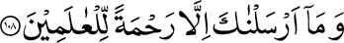
-------------
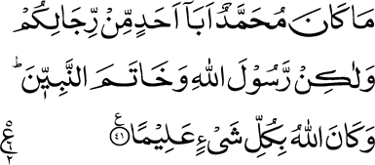
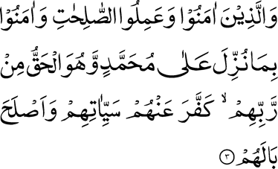

TRANSLATION:

[21:108] And We have sent thee not but as a mercy for all peoples.

[33:41] Muhammad is not the father of any of your men, but he is the Messenger of Allah and the Seal of the Prophets; and Allah has full knowledge of all things.

[47:3] But as for those who believe and do good works and believe in that which has been revealed to Muhammad — and it is the truth from their Lord — He removes from them their sins and improves their condition.

7:45 PM CHAIRMAN:

Let us now watch a brief Video introducing the Ahmadiyya Muslim Community.

http://www.youtube.com/watch?v=BGI4e83QBzE

7:55 PM CHAIRMAN’S INTRODUCTION:

Let me now invite ….......................... to come and recite a few couplets from an Arabic Poem in praise of the Holy Prophet Muhammad (may peace and blessings of Allah be upon him). A translation will be given at the end. This poem was written by Hazrat Mirza Ghulam Ahmad of Qadian, peace be on him, the Holy Founder of the Ahmadiyya Muslim Community.

QASEEDA (10);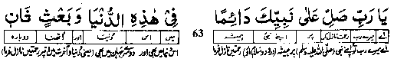
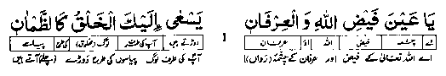
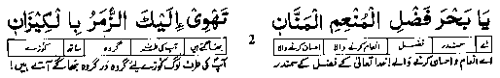
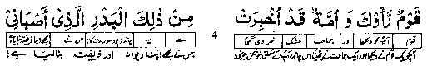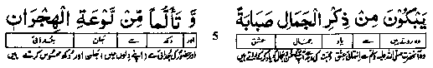
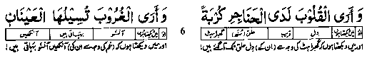
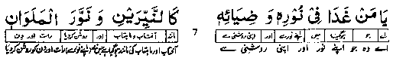
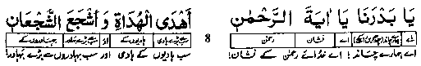

8:05 PM CHAIRMAN: Let me now ask …................. to come a read a translation of these couplets.

Qaseeda Translation:

O my Lord! Shower Your eternal blessings on Your Prophet --- In this life, as well in the Next Life.

O (you who are) the Fountain of Allah's munificence, and perfect understanding of Allah, People rush towards you, craving to satisfy their thirst.

O (you who are) the Ocean of God's grace --- God, Who is the Bestower of Favours, exceedingly Beneficent; Huge numbers of (thirsty) people hurry towards you holding their bowls (in hand).

O (you who are) the Sun of the (spiritual) Kingdom of Beauty and Grace!
You have (spiritually) illuminated the deserts as well as the cities.

A (group of) people (was fortunate that they) saw you, while others simply heard about you: Your are like The (enchantingly beautiful) Full Moon and you have cast a spell over me.

Inspired by (your) love (O Holy Prophet), people tearfully recall your beauty; And their aching hearts are afire, due to being distant from you.

I see that (their) hearts (are beating) in (such) anxiety (as if they) have reached their throats; And I see that (their grieving) eyes shed tears.

O you whose Divine Light and luminescence has rendered him like
The twin luminaries --- the Sun and the Moon --- lighting up day as well as night.

O our Full Moon, O Sign of the Gracious God! O (you who are) the Greatest (spiritual) Guide, the Bravest among the brave.

O my Lord! Shower Your eternal blessings on Your Prophet --- In this life, as well in the Next Life.

8:15 PM CHAIRMAN: Let me now invite ….................. to make a brief presentation on the Life of Muhammad (sa):

Speech (15):

AssalamoAlaikum! Greetings of peace everyone!

Muhammad, may peace and blessings of God be upon him, was born in the year 570 of the Christian Era in Arabia. He was born an orphan. His father passed away before his birth. His mother also died a little while after his birth and he was brought up under the care of his grandfather till he too passed away and his care transferred to his uncle.

Muhammad was known to be gentle, patient, and obedient, respectful toward his elders, affectionate with his companions, and full of compassion for those who, on account of age, infirmity, or adversity, stood in need of help.

As he grew to manhood, his contemporaries were impressed by his complete integrity, in word and deed, and he became generally known among them as "El‑Ameen," meaning "the Trustworthy."

He lived a simple, austere life. When he was 25, he married a rich widow 15 years his senior, but continued living his erstwhile simple and austere life happily with her after giving away almost all the wealth and slaves that she had given over to him upon marriage.

He was an embodiment of one whose purpose in life was to serve. In this sense he was the best example of what God tells the believers their purpose is.

The Holy Quran says (3:111):

Kuntum khaira ummatin ukhrayjat lin-nasay....

You are the best people raised for the good of mankind;

Note here the statement is made about the whole of mankind - not just Muslims...

Addressing the believers God tells them that they can be the best people only if they serve the whole of mankind...this is to be their hallmark.

I shall try in the following few minutes to just present some accounts from his multi-faceted life to show us all why it is that Muhammad (peace be on him) is so loved by all who know him.

One of the most well known of the Holy Prophet Muhammad’s (peace be on him) saying is “Sayyadul qaumay khaday-mo-hum.”

He says, “the leader of a people is the one who serves them.”

So if the leader is told to serve then everyone must also follow suit and set about the service of mankind and this is what the Holy Prophet Muhammad (peace be on him) did all his life.

He declared life sacrosanct. In another of his most famous sayings he declared that “the life, property, and honor of every human being is sacred.”

Abdullah bin Umar, a Companion of Prophet Muhammad (sa) relates that someone asked him, “which people were the most dear to God and what actions are most loved by God?” The Prophet replied: God loves most the person who provides the greatest benefit to others. And the best of deeds is the one by which a fellow Muslims becomes happy or some difficulty of his is removed or he is relieved of a debt or his hunger is satisfied.”

He is reported to have said that “I am so much happier helping to remove the difficulty of a Muslim brother than I would be sitting for a month involved in devotion to God in my Mosque in Medina.”

What this is meant to convey is that God is so much happier to learn of one’s service to humanity than simple acts of worship while sitting in a mosque.

The Holy Prophet Muhammad (peace be on him) was a member of a group of young men who had come together and taken an oath to help anyone who came to them to get justice. This was an oath he had taken long before he was commissioned to be a Prophet by God. But he fulfilled the demands of this oath even after he became a Prophet and started to face severe unrelenting opposition and persecution. He had told everyone that even now if a person was to come to him asking for assistance to correct an injustice he would not hesitate a moment to go to his aid despite all the opposition and persecution that he was now facing. And he fulfilled this even when a person came to ask for his assistance against his arch enemy Abu Jahl.

The Holy Prophet Muhammad (peace be on him) desired to serve everyone. It did not matter to him whether the person in need was Muslim or non-Muslim. His life is full of such incidents.

Once a person came and asked his help. He asked the people to help him and the people provided the man with clothing.

A man came and said I have suffered immense loss in my fruit business and so the Prophet made an appeal and the people collected a large sum of money for the man but it was insufficient. So the Holy Prophet asked the people who had lent him money to forgive his loans.

Once someone gave the Prophet a gift of ten dirhams. So he bought a shirt with four of these dirhams and put it on but when he came out of his house with the shirt on and it looked so very beautiful, a Companion asked him for the shirt. So he took it off and gave it to him. [In another narration it is said that the other Companions became upset with this man and scolded him severely for asking for the shirt but this man swore in the name of God that he had asked for it as a blessed memento for his survivors to use to wrap his body upon his death]

In any case the Prophet went out and bought another shirt with four of the dirhams from the six he had left. When he returned home he found a small girl, who was a servant in some household, was there, crying. He inquired as to why the girl was crying and found out that she had been given 2 dirhams by her master to go and buy some flour but she had lost the money. So he gave her the two dirhams he had left and started to leave but the girl again started crying. He asked her why she was crying now and she told him that she would be severely reprimanded or beaten by her master upon returning so very late. So he told her, “I will go with you,” and so he went to her house with her and interceded on her behalf and asked that she not be punished. The people of the household were overjoyed at seeing the Prophet and decided not only to forgive her but gave her, her freedom. The Prophet responded, “look how much God has blessed these ten dirhams. A Companion was blessed with a shirt. The Prophet was blessed with a shirt and a slave was given her freedom.”

Once while the Holy Prophet was sitting with some of his Companions, a group of very poor people came - they had on no shoes and were almost half naked, hungry and thirsty. Seeing their plight brought signs of grief and pain on his blessed countenance and he ordered Bilal to make the call to Prayer and then he led the Prayer service and made an appeal to all who had come to offer the Prayer. The people brought money, clothes, grains, dates and different sorts of things and made heaps out of them. Seeing this, the Prophet’s face became happy and shone with satisfaction.

He would say always that the worst type of feast was the one to which only the rich are invited and the poor are forgotten.

There are many sayings that tell us how the Holy Prophet (peace be on him) would arrange the marriages of poor boys and girls and on the occasion of their marriages he would help in every way possible. In some circumstances he would give to the newly married couples all the rations and things in his own house and would go hungry himself.

Whenever the Holy Prophet would learn of the illness of anyone, whether rich or poor, he would go to see the person and give them encouragement and sit with them and listen to them and give them strength and courage and pray for them and, if he saw the need, he would make better arrangements for their food.

What was the normal routine condition of his own household can be gauged from this amazing incident.

It is said once that when the Holy Prophet returned home his wife Hazrat Ayesha was very excited to tell him the story of a woman who had come to their house with her two daughters - all very hungry, saying that they had not eaten anything for days. She told the Prophet that she had found nothing in the house except one date - so Hazrat Ayesha said I gave that one date to the lady and saw with wonder how she divided the date into two halves and gave each piece to her two daughters. So here was Hazrat Ayesha praising the sacrifice of the lady, quite oblivious of the fact that they themselves had to go hungry as a result.

The Holy Prophet was extremely kind even to animals. Once on a journey, he heard cries of a small bird in distress. He turned to his companions and asked what had happened to the bird.
One of them said that he had taken two eggs from her nest. The Holy Prophet said: "Return them immediately." In another narration of the same incident it is said that two chicks and not
eggs had been taken, and the Holy Prophet said to his companions that no mother should ever be pained on account of her offspring.

The Holy Prophet once narrated an incident to his companions: "A man who was thirsty in a desert discovered a well full of water. He climbed down and drank his fill. Upon coming out, he observed a dog panting with thirst, perhaps about to die. He went back in and filled his shoes with water, then holding them in his teeth, returned to the surface and quenched the thirst of the dog. The Holy Prophet said: "God has told me that this man was pardoned for all his previous sins." In another narration it is said that it was a prostitute who did this. Her whole life was full of sins, but she was pardoned in the sight of God for an act of kindness to an animal.

These are just a few incidents from the life of the Holy prophet that is full of such things.

He was a personification of service.

His love for humanity knew no bounds and all who were around him knew this themselves. It was this unbounded love that won him their hearts and minds and souls and helped him transform them from bedouins buried in the earth into spiritual beings capable of soaring to the highest pinnacles of spiritual advancement.

Those who love God, love His creation and their love does not remain confined to their lips and does not discriminate - their love is as indiscriminate as the Love, Grace and Mercy of God is indiscriminate and free for all. Just as God has blessed all the people of the earth with His limitless bounties - so the love of those who truly believe in the One God Who has created us all is indiscriminate and available to all.

And the Greatest exemplar of these was indeed Muhammad who is, for this reason, described in the verses that were recited from the Holy Quran at the outset as having been sent as a “Mercy for all the peoples of the world.”

Thank you for your time. I hope and pray that all of you will delve into a study of the life story of Muhammad - may peace and blessings of Allah be upon him - and thus understand why so many millions upon millions of people love him so very dearly.

8:30 PM CHAIRMAN:

Thank you Mr...................................... for this wonderful brief address.

It is in the spirit of all that our esteemed speaker has said that we, the members of the Ahmadiyya Muslim Community, are dedicated worldwide to doing all we can, in the service of humanity.....

We will now watch a few short clips from the activities of Humanity First. This is a non-profit global sister organization of the Ahmadiyya Muslim Community that aims to relieve suffering caused by natural disaster and human conflict with the aim of promoting peace and understanding in ways that strengthen the people’s capacity to help themselves.

VIDEO: http://youtu.be/NcA7BmJrnDI

8: 40 PM CHAIRMAN:

These were short clips on the work of Humanity First. The Ahmadiyya Muslim Community has, since its founding, upheld the sanctity of all life as emphasized by Islam. The Holy Quran teaches that life is sacred and reaffirms Biblical teaching that whoever unjustly kills a single person is as if he had killed all of mankind; and whoever saves the life of one person is as if he has saved the life of all of humanity (5:33). In his Farewell Pilgrimage address, the Holy Prophet Muhammad (peace and blessings of Allah be upon him) said, “Even as this month, land and day of Pilgrimage are holy, so has God made the blood, property and honor of every human being sacred.”

Let us now watch a short video report on the FIRST ever Nationwide Muslims for Life Blood Drive that was conducted in the USA in 2011. A second effort was done in 2012 and now this has become a wonderful ANNUAL event which will again be organized this year from August 11, 2013 till September 11, 2013.

[play video]

http://www.youtube.com/watch?v=_bDcpQUBWNI

9:00 PM: CHAIRMAN:

I hope everyone enjoyed this enlightening presentation on the Muslims for Life nationwide blood drives - a unique event I think attempting to help save thirty thousand plus lives every year with the collaboration of hundreds of other organizations..this is something I think that is the most appealing aspect of all this work for me..God bless everyone involved in this great work and may it go on growing and expanding every year.

Thank you again.

It gives me now, great pleasure, in asking our special guests to please come to the stage and accept a small gift from us and say a few words to all of us...

May I ask …...….... to come to the stage please ..

….

Thank you ….

I now ask …..... to come to the stage please ..

…..

Thank you...

I hope and pray that everyone in the audience has also received their own gift. This includes a copy of the “Life of Muhammad(sa)” that we hope you will all enjoy reading.

Before we go and enjoy the light refreshments prepared for all of us let us have a short Q and A session...

9:05 PM: Q & A Session (15 - 30)

We have given to everyone cards to write their questions on and hand over to the young men coming to get them...once we receive these we will have our distinguished panel answer some of these questions.

While you are writing your questions and they are collected may I please ask the following members of the panel to please join me on the stage:

Imam...................
Mr. …......, President of our local Chapter
and let me also ask Mr. …........................ head of our young men’s association to please come to the stage.

Thank you.

[questions to be read out and answers to be given....15 to 30 minutes..]

Thank you everyone. This has been a most enlightening session. I want to ask everyone who had more questions to please feel free to ask us as we enjoy the light snacks prepared for us and also let me ask you all to please visit our website: www.MuslimsForPeace.org where you will be able to learn a lot more about the Life of Muhammad (sa) and also where you will be able to visit other links: www.MuhammadFactCheck.org where facts about the life of Muhammad (sa) are checked and verified against historical records and common sense.

It is now my pleasure to thank all of you and all of the organizers who helped bring this event about. may God bless us all.

It is customary for us all to end by raising our hands and joining together to make a silent prayer.

Dua...silent prayer please...

...silence....

Assalamoalaikum Everyone --- Greetings of peace and again thank you and God bless us all.

9:15/9:30 PM: LIGHT SNACKS & REFRESHMENTS.

