Document ID : 002
Title: How to setup initial login for ahmadiyya.us email address?

Steps:
You would have received an email from the admin which would look like below
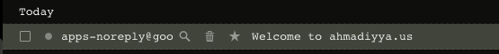

Open the email and follow the link to login
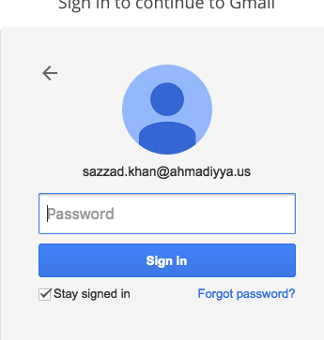

Enter password provided in the email and click sign-in
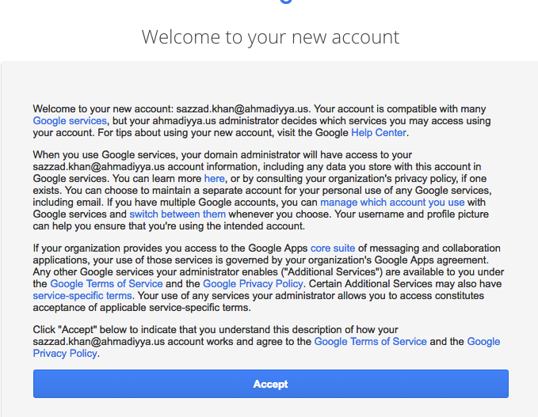
Click Accept to accept the terms of usage
First time login will require you to change the password. Please change the password and safekeep it.
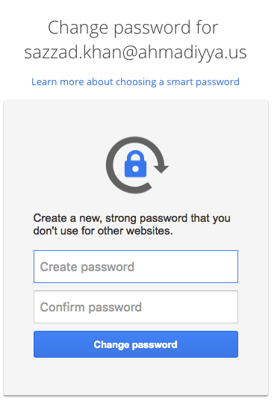
As an option, you an add a phone # for recovering lost password. If selecting this option, google will send a SMS text code, enter the code in the box provided and proceed to next step.
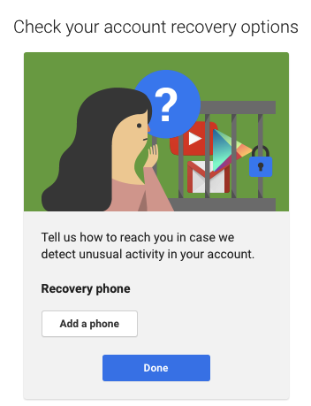
Change your Signature by clicking on the Cog on the right and selecting Settings.
Click on General Tab and add your signature the box as shown below. Click save when done.
